ECA10 – MICROPROCESSOR AND MICROCONTROLLER
CO1 CONSTRAINT-BASED PROBLEM-SOLVING ASSESSMENT
Assignment – 1
ENGINEERING DESIGN REPORT
Constraint-Based Problem Solving with 8-bit Processor (Intel 8085) Assembly Language Programming – 8-bit Monitoring and Control Unit for an Equipment Room
Item | Details
Course Outcome | CO1 – Microprocessor architecture, instruction-set classification and addressing modes
Processor used | Intel 8085 (8-bit microprocessor)
Program origin / size | 2000H – 2042H ; 67 bytes (43H) against the 256-byte limit
Name / Register No. | Daniel Sam K ( 192524081 )
Date of submission | 28/10/2026

Report flow: REQUIREMENT → ARCHITECTURE → INSTRUCTION CLASSIFICATION → OPERATIONAL LOGIC → ADDRESSING-MODE SELECTION → ALGORITHM → ALP DESIGN → EXECUTION-CYCLE ANALYSIS → TESTING → ENGINEERING DECISION
No simulator, assembler, emulator or Proteus has been used. All instruction selection, addressing-mode analysis, calculations and expected results are worked out manually.

0. Design Assumptions and Interpretation of the Specification
The problem statement leaves a few details open (and uses a few slightly different location names in different places). The following assumptions are fixed once, at the start, and are used consistently throughout the report.
No. | Assumption / interpretation | Reason
A1 | Processor = Intel 8085. Instruction mnemonics, opcodes and T-states are those of the 8085. | The brief demands an Intel 8-bit processor with registers A, B, C, D, E, H, L.
A2 | Input 1 (temperature) = [2050H]; Input 2 (humidity) = [2051H]; Threshold = [2052H] = 10H; Mask = [2053H] = 0FH. | As given in the specification table; 10H is the “Record” value of the three test cases.
A3 | Status byte → 3050H (00H NORMAL, 01H WARNING, 02H CRITICAL). 8-bit sum → 3051H. Masked result → 3060H. | The specification table assigns 3050H to status and 3051H to the arithmetic result; the verification table’s “mask update 3060H onward” gives the masked-result address.
A4 | FAN / ALARM / HUMIDIFIER control bits are held in one byte at 3052H: bit 0 = FAN, bit 1 = ALARM, bit 2 = HUMIDIFIER. | 3051H is already used for the arithmetic result, so the control-bit byte is placed at the next free address, 3052H. This resolves the 3051H wording in the verification table.
A5 | Classification of the 8-bit sum S: S < Threshold → NORMAL; Threshold ≤ S < 2 × Threshold → WARNING; S ≥ 2 × Threshold, or the addition produces a carry → CRITICAL. | Only one threshold is available in memory (2052H); the critical limit is therefore derived from it (2 × 10H = 20H). Test data (08H, 11H, 35H) fall in the three bands.
A6 | Control-bit pattern: NORMAL = 00H (all off); WARNING = 05H (FAN + HUMIDIFIER); CRITICAL = 07H (FAN + ALARM + HUMIDIFIER). | FAN ventilates at the first sign of rising load, HUMIDIFIER regulates humidity, ALARM is raised only for the critical state.
A7 | Threshold ≤ 7FH so that 2 × Threshold fits in 8 bits. Sensor values are unsigned. | Keeps the critical-limit calculation a single ADD A and allows unsigned (carry-flag) comparison.
A8 | Executable code is placed from 2000H; data area starts at 2050H. | Code (≤ 256 bytes) ends well before 2050H, so code and data do not overlap.

STAGE 1 – INTERPRET THE SYSTEM REQUIREMENT

1.1 Role of the 8-bit processor in the system
The 8085 is the central decision-making element of the Monitoring and Control Unit. It (i) fetches the two 8-bit sensor values from memory, (ii) adds them, (iii) compares the 8-bit sum with the stored threshold, (iv) selects the NORMAL / WARNING / CRITICAL condition, (v) generates the FAN / ALARM / HUMIDIFIER control byte, (vi) applies the stored bit mask to the sum, and (vii) writes the status, result, control byte and masked result back to memory. The major functional blocks involved are the sensor/input data area, the processor (ALU, registers, control unit), the program/data memory and the output (status/control) area, as shown in Fig. 1 and Fig. 2.
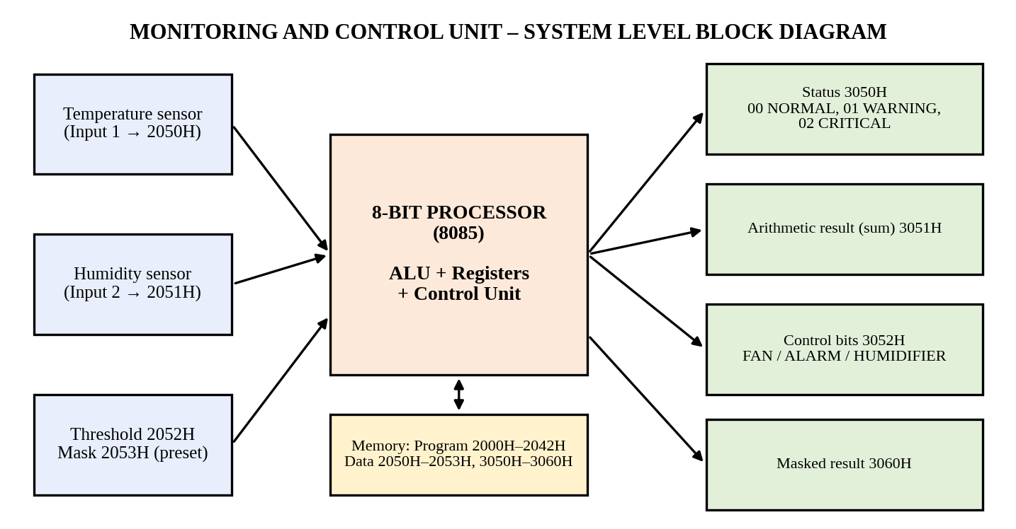
Fig. 1 System-level block diagram of the Monitoring and Control Unit

1.2 Participation of ALU, control unit, registers and buses
Block | Function in this system
ALU | Performs ADD (T + H), ADD A (2 × threshold), CMP (subtraction without storing the result, used to set CY/Z), ORI and XRA (control-bit generation) and ANA (masking). Updates the flag register.
Accumulator (A) | Holds the first operand and every ALU result; all arithmetic and logic instructions use A implicitly.
Flag register (S, Z, AC, P, CY) | CY after ADD detects overflow; CY after CMP gives the unsigned ‘less than’ decision; Z identifies equality.
Register array B, C, D, E, H, L | B keeps the sum, C the threshold, D the critical limit then the status, E the control bits, HL the memory pointer (see Table 5.3).
Program Counter / Instruction Register / Decoder | PC holds the address of the next instruction; the opcode is latched in the IR and decoded by the control unit, which issues the timing and control signals.
Timing and control unit | Generates ALE, RD, WR and IO/M for every memory read/write machine cycle, and loads the PC on a taken branch.
Address bus (A15–A8) and multiplexed AD7–AD0 | The 16-bit memory address (e.g. 2050H, 3051H) is placed on the address lines; AD7–AD0 carry the low address first and then the 8-bit data (sensor value or result).
Internal 8-bit data bus | Moves operands between registers, the temporary register, the ALU and the accumulator.

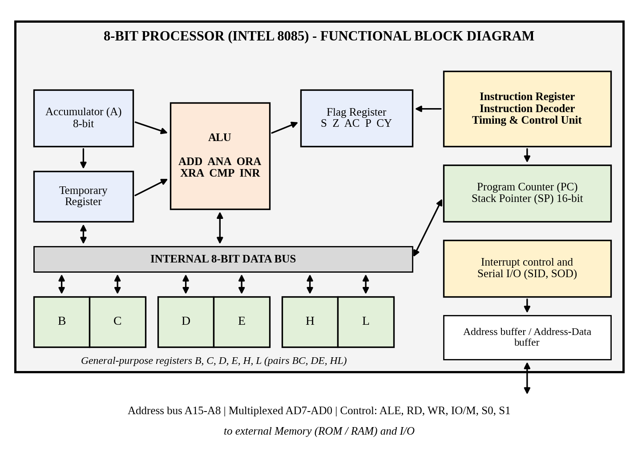
Fig. 2 Labelled functional block diagram of the 8-bit processor (8085)

1.3 Why the 8-bit processor is suitable
- The sensor values, threshold, mask, status and result are all 8-bit quantities, so each is handled by one register or one memory byte in a single operation – no multi-byte (multi-precision) arithmetic is required.
- The accumulator-based ALU provides ADD, compare and logical operations directly on 8-bit data, with flags available for decision making.
- Register-indirect access through HL and direct 16-bit addressing allow the 64 KB address space to be reached with very short code.
- Single +5 V supply, on-chip clock generator and low cost make the 8085 adequate for a simple, non-time-critical equipment-room monitor (a 3 MHz clock gives microsecond-level response).

1.4 Input → Processing → Decision → Output flow
Stage | Operation | Memory / register involved
Input | Read temperature and humidity; read threshold and mask | [2050H], [2051H], [2052H], [2053H]
Processing | Sum = Temperature + Humidity (8-bit, carry checked); critical limit = 2 × threshold; masked result = Sum AND Mask | A, B, C, D ; flags CY, Z
Decision | Carry or Sum ≥ critical limit → CRITICAL; Sum ≥ threshold → WARNING; otherwise NORMAL | Flags CY after ADD and CMP
Output | Write status, sum, control bits and masked result | [3050H], [3051H], [3052H], [3060H]

1.5 Constraints influencing the design
Constraint | Influence on the design
Instruction constraint (data transfer, arithmetic, logic, branch) | At least one instruction of every class must appear: MOV/LXI/STA, ADD/INX, ANA/ORI/XRA, JC/JNC/JMP.
Memory constraint (≤ 256 bytes of code) | Short instructions are preferred (1-byte register-indirect forms instead of 3-byte direct forms); no subroutines, no duplicated code; final size 67 bytes.
Register constraint (A, B, C, D, E, H, L only) | The 8-bit registers must be shared; D is reused (critical limit, then status). HL is used as a pointer pair.
Addressing constraint | Immediate, register, direct, register-indirect and implied modes must all be demonstrated and justified.
8-bit data constraint | Sum can overflow beyond FFH, so the carry flag must be tested; the stored result is truncated to 8 bits.
No tools | All register/flag/memory values are traced manually.

1.6 Evolution of microprocessors
Stage | Year / example | Key features | Engineering improvement
Early microprocessor | 1971 – Intel 4004 (4-bit) | 2,300 transistors, 4-bit data, about 740 kHz, 46 instructions | First complete CPU on one chip; replaced hard-wired logic by a programmable one.
8-bit generation | 1976 – Intel 8085 | 8-bit data, 16-bit address (64 KB), on-chip clock generator, single +5 V supply, 5 interrupts, serial I/O lines | Fewer support chips, lower system cost and better interrupt handling than the 8080 – ideal for control applications like this one.
16-bit generation | 1978 – Intel 8086 | 16-bit data, 1 MB memory via segmentation, instruction pre-fetch queue | Fetch overlapped with execution (pipelining) and larger memory.
Modern processors | Multi-core 32/64-bit CPUs | Cache memory, superscalar/pipelined execution, multiple cores | Large gains in speed and throughput through parallelism and caching.

Stage 1 Deliverable – System Requirement Statement
System Requirement Statement: An 8085-based Monitoring and Control Unit shall read two unsigned 8-bit sensor values from 2050H and 2051H, add them to an 8-bit result stored at 3051H, compare the sum with the threshold stored at 2052H (critical limit = 2 × threshold, or an addition carry), and write the status 00H/01H/02H (NORMAL/WARNING/CRITICAL) at 3050H, the FAN/ALARM/HUMIDIFIER byte at 3052H and the sum AND mask (mask at 2053H) at 3060H. The executable logic shall not exceed 256 bytes, shall use only registers A, B, C, D, E, H and L, and shall use at least one data-transfer, arithmetic, logic and branch instruction and the immediate, register, direct, register-indirect and implied addressing modes.

STAGE 2 – CLASSIFY AND SELECT INSTRUCTIONS
Table 2.1 Instruction-selection table
Required operation | Class | Selected instruction(s) | Addressing mode | Flags / 8-bit data handling | Reason for selection
Read temperature / humidity | Data transfer | LXI H,2050H ; MOV A,M ; INX H ; ADD M | Immediate (LXI), register indirect (MOV A,M, ADD M) | MOV, LXI, INX do not affect flags | HL pointer reaches both inputs with 1-byte instructions; INX H moves to 2051H; ADD M adds directly from memory.
Compare with limits | Arithmetic / compare | CMP D ; CMP C | Register | Sets CY (=1 if A < operand), Z (=1 if equal), S, P, AC; A unchanged | Non-destructive: the sum stays in A for the second comparison and no restore is needed.
Increment event counter (optional routine) | Arithmetic | LXI H,3070H ; INR M | Immediate, register indirect | INR affects S, Z, AC, P but NOT CY; 8-bit wrap FFH → 00H | Increments the counter directly in memory with a single 1-byte instruction.
Generate / clear control bits | Logic | XRA A ; ORI 05H / 07H ; (ANA/CMA available for clearing/inverting) | Register, immediate | XRA A: A = 0, Z = 1, CY = 0. ORI sets the required bits and clears CY | XRA A clears all bits in one byte; ORI sets only FAN/ALARM/HUMIDIFIER bits without disturbing others.
Select NORMAL / WARNING / CRITICAL | Branch / program control | JC, JNC, JMP | Immediate (16-bit address in instruction) | Depends on CY (unsigned comparison); JMP unconditional | JC after ADD detects overflow; JNC after CMP selects the band; NORMAL is the fall-through path.
Copy values to display buffer (optional routine) | Data transfer | MOV A,M ; STAX D ; INX H ; INX D | Register indirect via HL and DE | None of these affect flags | Copies status, sum and control bytes to a buffer at 3080H without using 3-byte direct instructions.
Loop over display buffer (optional routine) | Branch / program control | DCR C ; JNZ LOOP | Register / immediate address | DCR sets Z when the counter reaches 0 (CY unchanged) | The 8085 has no relative jump; JNZ with an absolute address is the loop control.

Optional display-buffer routine (not part of the 67-byte main program): LXI H,3050H ; LXI D,3080H ; MVI C,03H ; LOOP: MOV A,M ; STAX D ; INX H ; INX D ; DCR C ; JNZ LOOP. It occupies 16 bytes, so the total even with this routine (83 bytes) remains far below 256 bytes. The event counter needs only LXI H,3070H ; INR M (4 bytes).
Table 2.2 Classification of all instructions used in the main program
Instruction | Opcode | Bytes | T-states | Class | Flags affected
LXI H,2050H / 2052H / 2053H | 21 | 3 | 10 | Data transfer | None
MOV A,M | 7E | 1 | 7 | Data transfer | None
MOV B,A ; MOV C,A ; MOV D,A ; MOV E,A | 47, 4F, 57, 5F | 1 | 4 | Data transfer | None
MOV A,B ; MOV A,D ; MOV A,E | 78, 7A, 7B | 1 | 4 | Data transfer | None
MVI D,01H / 02H | 16 | 2 | 7 | Data transfer | None
STA 3050H / 3051H / 3052H / 3060H | 32 | 3 | 13 | Data transfer | None
INX H | 23 | 1 | 6 | Arithmetic (16-bit) | None (8085)
ADD M | 86 | 1 | 7 | Arithmetic | S, Z, AC, P, CY
ADD A | 87 | 1 | 4 | Arithmetic | S, Z, AC, P, CY
CMP C ; CMP D | B9, BA | 1 | 4 | Arithmetic / compare | S, Z, AC, P, CY
XRA A | AF | 1 | 4 | Logical | S, Z, P set; CY = AC = 0
ORI 05H / 07H | F6 | 2 | 7 | Logical | S, Z, P; CY = 0, AC = 0
ANA M | A6 | 1 | 7 | Logical | S, Z, P; CY = 0, AC = 1
JC CRIT ; JNC CRIT ; JNC WARN | DA, D2 | 3 | 10 taken / 7 not taken | Branch (conditional) | None
JMP DONE | C3 | 3 | 10 | Branch (unconditional) | None
HLT | 76 | 1 | 5 | Other / machine control | None

2.1 Alternative instructions that were rejected
Alternative | Why it was rejected under the constraints
LDA 2050H ; MOV B,A ; LDA 2051H ; ADD B (direct addressing for the inputs) | Needs 3 + 1 + 3 + 1 = 8 bytes and 13 + 4 + 13 + 4 = 34 T-states, compared with LXI H ; MOV A,M ; INX H ; ADD M = 3 + 1 + 1 + 1 = 6 bytes and 10 + 7 + 6 + 7 = 30 T-states. It also needs an extra register (B) for the temporary operand. Works, but wastes memory and time.
SUB / SUI to compare the sum with the threshold | SUB destroys the accumulator content, so the sum would have to be saved and restored (extra MOV instructions) before the second comparison. CMP gives the same CY/Z flags without changing A.
CPI 10H (immediate compare with a fixed threshold) | Hard-codes the threshold in the program. The specification stores the threshold in memory at 2052H so that it can be changed without re-programming; CPI would violate this requirement.
CALL / RET subroutines for the three states | Needs stack initialisation (LXI SP), 18 T-states per CALL and 10 per RET, extra bytes, and offers no reuse because each state is executed only once. Rejected for memory and time.
JZ / JM / JP (zero or sign-flag decisions) | Equality (Z) alone cannot separate ‘below’, ‘between’ and ‘above’ bands; the sign flag is meaningful only for signed data, whereas the sensor data are unsigned. CY is the correct flag.

STAGE 3 – DESIGN THE OPERATIONAL LOGIC

3.1 Decision tree
The decision is made on the 8-bit sum S, the threshold Th = [2052H] and the derived critical limit CL = 2 × Th = 20H:
- If the addition produced a carry (CY = 1 after ADD M) → CRITICAL (the true sum exceeds FFH).
- Else if S ≥ CL (CMP D leaves CY = 0) → CRITICAL.
- Else if S ≥ Th (CMP C leaves CY = 0) → WARNING.
- Else (S < Th) → NORMAL.
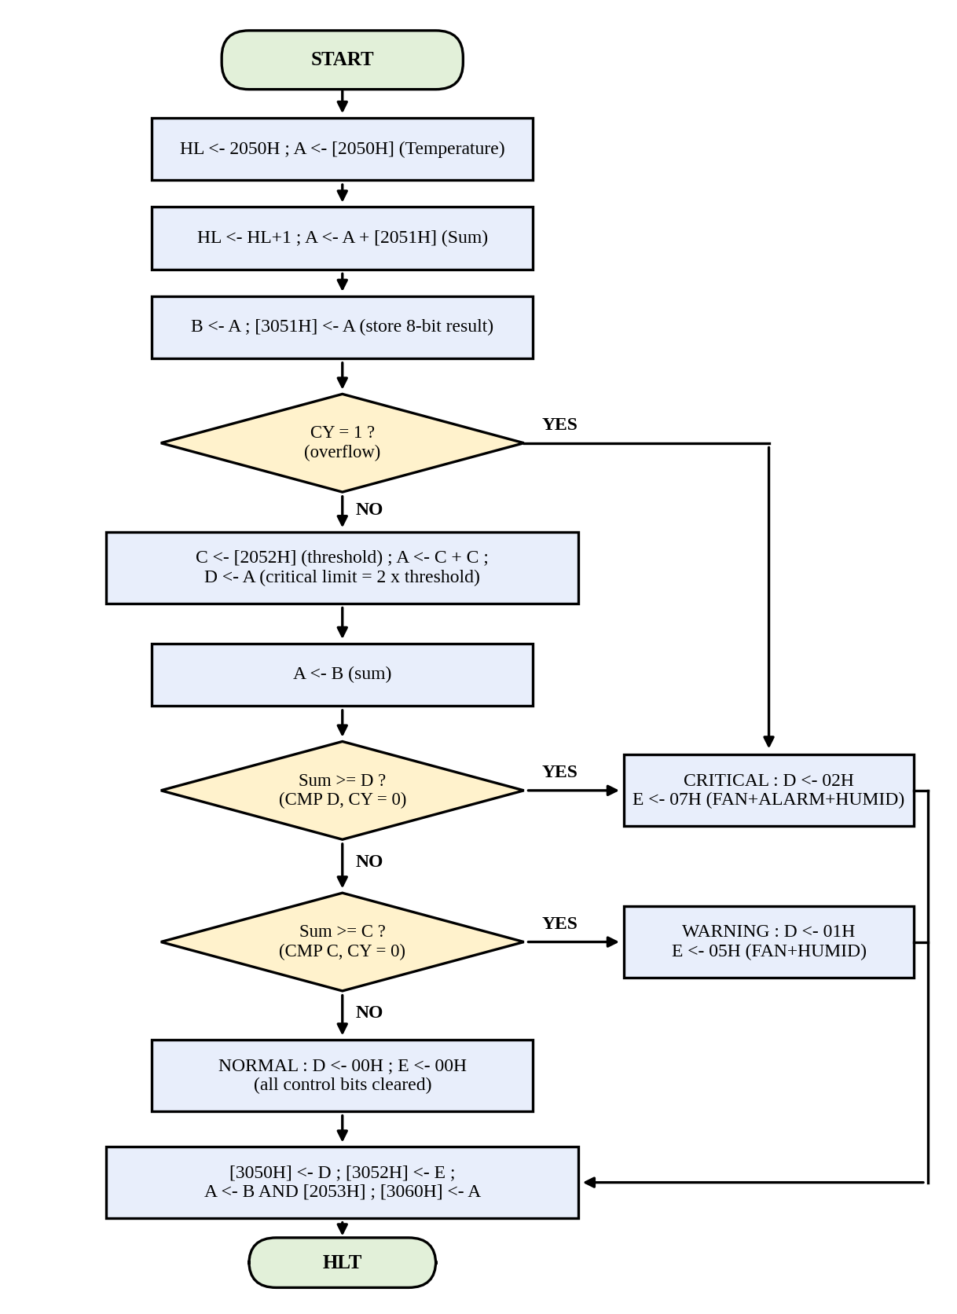
Fig. 3 Flowchart of the operational logic

3.2 Conditions for the FAN, ALARM and HUMIDIFIER bits
Condition | Status [3050H] | FAN (bit 0) | ALARM (bit 1) | HUMIDIFIER (bit 2) | Control byte [3052H]
S < Th | 00H NORMAL | Cleared (0) | Cleared (0) | Cleared (0) | 00H
Th ≤ S < 2 × Th | 01H WARNING | Set (1) | Cleared (0) | Set (1) | 05H (0000 0101)
S ≥ 2 × Th, or carry | 02H CRITICAL | Set (1) | Set (1) | Set (1) | 07H (0000 0111)

3.3 Flags used by the comparison and branch instructions
Flag | Set / reset by | Used for
CY (Carry) | ADD M: CY = 1 if the sum exceeds FFH. CMP r: CY = 1 if A < r (unsigned borrow). | JC after ADD (overflow → CRITICAL). JNC after CMP D / CMP C (A ≥ operand → branch).
Z (Zero) | CMP r sets Z = 1 when A = r (e.g. S = Th = 10H). | Boundary case: S = Th gives CY = 0, so the branch is taken and the state is WARNING (limit is inclusive).
S, P, AC | Updated by ADD, CMP and logic instructions. | Not used for decisions (S is meaningful only for signed data). Shown in the traces for completeness.

3.4 How arithmetic, logic and branch instructions work together
The arithmetic group (ADD M, ADD A, CMP) converts the raw sensor values into the sum, the critical limit and the CY flag. The branch group (JC, JNC, JMP) reads CY and steers the program counter to the NORMAL, WARNING or CRITICAL block. The logical group (XRA A, ORI) then builds the control byte for the selected state, and ANA M applies the stored mask to the sum. Data-transfer instructions move the operands and finally store the status, control byte, sum and masked value in the specified memory locations.

3.5 Minimum processing steps and redundant operations
The minimum number of major processing steps is ten: (1) point to the inputs and read the temperature, (2) add the humidity, (3) save the sum in B and store it at 3051H, (4) test the carry, (5) read the threshold, (6) derive the critical limit, (7) compare with the critical limit, (8) compare with the threshold, (9) build and store the status and control byte, (10) mask the sum and store it at 3060H.
Redundant operations eliminated: (a) the sum is kept in B, so it is never re-loaded from 3051H; (b) CMP is used instead of SUB, so no restore of A is needed; (c) the critical limit is calculated once with ADD A instead of being stored as a second threshold; (d) NORMAL is the fall-through case, so it needs no compare; (e) the final store/mask block is common to all three states (reached by fall-through or one JMP) and is not duplicated; (f) HL is loaded once for the two inputs, using INX H instead of a second LXI.

Design Decision 1 – Branch strategy
Recommended strategy: test the overflow carry first, then compare against the highest limit first (critical), then the threshold (warning), and let NORMAL fall through; all branches use CY (JC/JNC) and the three paths merge in a common DONE block.
- Correctness: the carry test comes straight after ADD M, before any other flag-changing instruction (MOV and STA do not change flags), so overflow cannot be missed. Testing the highest band first makes the bands mutually exclusive: no value can fall in two states.
- Readability: three clearly labelled blocks (NORMAL, WARNING, CRIT) and one common DONE block; the decision tree maps one-to-one to the code.
- Instruction efficiency: only 3 conditional branches and 1 JMP are needed; NORMAL needs no compare; the CRIT block is placed immediately before DONE so that it needs no JMP at all (saves 3 bytes and 10 T-states on the critical path).

STAGE 4 – ADDRESSING-MODE SELECTION UNDER CONSTRAINTS
Table 4.1 Analysis of the addressing modes
Mode | Required task | Instruction and operand form | Analysis / suitability
Immediate | Load threshold / mask values; pointers and constants | LXI H,2050H (16-bit immediate); MVI D,01H; ORI 05H | The operand is part of the instruction – fastest for constants known at design time (addresses, status codes 01H/02H, control patterns 05H/07H). For the threshold and mask themselves (10H, 0FH), the specification keeps them in memory so they are read through HL; MVI C,10H would work but would hard-code the value, so it is less suitable.
Register | Intermediate calculations | MOV B,A ; MOV C,A ; ADD A ; MOV A,B ; CMP D | The operands are inside the CPU: 4 T-states and 1 byte per instruction, no bus access. B holds the sum, C the threshold and D the critical limit, so the two compares need no memory reads.
Direct | Access 2050H / 2051H / 2052H / 2053H / 3050H / 3051H (and 3052H, 3060H) | STA 3051H ; STA 3050H ; STA 3052H ; STA 3060H (LDA nnnnH is the alternative for reading) | The full 16-bit address is in the instruction (3 bytes, 13 T-states). Ideal for single, isolated stores to fixed output addresses; no pointer set-up is needed.
Register indirect | Access memory through HL | MOV A,M ; ADD M ; ANA M (address in HL) | HL acts as the memory pointer: 1-byte instructions, 7 T-states. HL is loaded once, and INX H reaches the next location, so the four input locations are read with the shortest code.
Implied | Accumulator / flag-related operation | HLT ; (CMA, STC, CMC, RAL are other implied instructions) | The operand is implicit in the opcode – no operand byte. HLT ends the program. Accumulator-implicit instructions such as XRA A / ADD A clear or double A; CMA / STC / CMC would be used if the hardware needed inverted (active-low) control bits or an explicit carry setting.

Design Decision 2 – Addressing mode chosen for each major data-access operation
Data-access operation | Chosen mode | Instruction
Set up address of the input block | Immediate | LXI H,2050H
Read temperature, humidity, threshold, mask | Register indirect | MOV A,M ; ADD M ; ANA M
Hold sum, threshold, limit, status, control bits | Register | MOV B,A ; MOV C,A ; MOV D,A ; MOV E,A ; MOV A,B
Store status, sum, control byte, masked result | Direct | STA 3050H, 3051H, 3052H, 3060H
Load constants (status codes, bit patterns) | Immediate | MVI D,01H ; ORI 05H
Stop | Implied | HLT

Cases where a different mode would work but is less suitable:
- Reading inputs with direct addressing (LDA 2050H, LDA 2051H). It works, but costs 8 bytes / 34 T-states against 6 bytes / 30 T-states for LXI + MOV A,M + INX H + ADD M, and needs an extra register for the temporary operand.
- Loading the threshold and mask with immediate addressing (MVI C,10H ; ANI 0FH). It would be shorter, but the values would be fixed in the program memory and the unit could not be re-configured by changing 2052H / 2053H, contrary to the specification.
- Storing outputs with register indirect addressing (LXI H,3050H ; MOV M,A). It takes 4 bytes / 17 T-states against 3 bytes / 13 T-states for STA 3050H, and it overwrites the HL pointer; STA is therefore better for single stores.

STAGE 5 – DEVELOP THE 8-BIT ASSEMBLY LANGUAGE PROGRAM

5.1 Algorithm / pseudocode
- Start; HL ← 2050H.
- A ← [HL] (temperature); HL ← HL + 1.
- A ← A + [HL] (humidity); the carry flag records any overflow.
- B ← A; [3051H] ← A (8-bit arithmetic result).
- If CY = 1 go to CRITICAL (overflow).
- C ← [2052H] (threshold); A ← C + C; D ← A (critical limit).
- A ← B; compare A with D. If A ≥ D go to CRITICAL.
- Compare A with C. If A ≥ C go to WARNING.
- NORMAL: A ← 0; D ← 0 (status); E ← 0 (control bits); go to DONE.
- WARNING: A ← 0 OR 05H; E ← A; D ← 01H; go to DONE.
- CRITICAL: A ← 0 OR 07H; E ← A; D ← 02H.
- DONE: [3050H] ← D; [3052H] ← E.
- A ← B AND [2053H] (mask); [3060H] ← A.
- Halt.

5.2 Assembly language program (origin 2000H)
Table 5.1 Complete program listing
Address | Machine code | Label | Mnemonic | Comment
2000 | 21 50 20 |  | LXI H,2050H | HL ← 2050H, pointer to temperature (immediate)
2003 | 7E |  | MOV A,M | A ← [2050H] = temperature (register indirect)
2004 | 23 |  | INX H | HL ← 2051H (implied/register pair)
2005 | 86 |  | ADD M | A ← A + [2051H] = sum; flags updated (CY = overflow)
2006 | 47 |  | MOV B,A | B ← sum (register)
2007 | 32 51 30 |  | STA 3051H | [3051H] ← sum (direct)
200A | DA 2C 20 |  | JC CRIT | CY = 1 (overflow) → CRITICAL; MOV and STA kept the flags
200D | 21 52 20 |  | LXI H,2052H | HL ← 2052H, pointer to threshold
2010 | 7E |  | MOV A,M | A ← [2052H] = threshold
2011 | 4F |  | MOV C,A | C ← threshold
2012 | 87 |  | ADD A | A ← 2 × threshold (critical limit)
2013 | 57 |  | MOV D,A | D ← critical limit
2014 | 78 |  | MOV A,B | A ← sum
2015 | BA |  | CMP D | Compare sum with critical limit; CY = 1 if sum < limit
2016 | D2 2C 20 |  | JNC CRIT | Sum ≥ critical limit → CRITICAL
2019 | B9 |  | CMP C | Compare sum with threshold; CY = 1 if sum < threshold
201A | D2 23 20 |  | JNC WARN | Sum ≥ threshold → WARNING
201D | AF | NORMAL | XRA A | A ← 00H (all control bits cleared)
201E | 57 |  | MOV D,A | D ← 00H (status NORMAL)
201F | 5F |  | MOV E,A | E ← 00H (control byte)
2020 | C3 32 20 |  | JMP DONE | Skip the WARNING and CRITICAL blocks
2023 | AF | WARN | XRA A | A ← 00H
2024 | F6 05 |  | ORI 05H | Set FAN (bit 0) and HUMIDIFIER (bit 2): A = 05H
2026 | 5F |  | MOV E,A | E ← control byte 05H
2027 | 16 01 |  | MVI D,01H | D ← status WARNING (immediate)
2029 | C3 32 20 |  | JMP DONE | Go to the common output block
202C | AF | CRIT | XRA A | A ← 00H
202D | F6 07 |  | ORI 07H | Set FAN, ALARM and HUMIDIFIER: A = 07H
202F | 5F |  | MOV E,A | E ← control byte 07H
2030 | 16 02 |  | MVI D,02H | D ← status CRITICAL (falls through to DONE)
2032 | 7A | DONE | MOV A,D | A ← status
2033 | 32 50 30 |  | STA 3050H | [3050H] ← status (direct)
2036 | 7B |  | MOV A,E | A ← control byte
2037 | 32 52 30 |  | STA 3052H | [3052H] ← control byte (FAN/ALARM/HUMIDIFIER)
203A | 21 53 20 |  | LXI H,2053H | HL ← 2053H, pointer to the mask
203D | 78 |  | MOV A,B | A ← sum
203E | A6 |  | ANA M | A ← sum AND [2053H] (bit mask, register indirect)
203F | 32 60 30 |  | STA 3060H | [3060H] ← masked result
2042 | 76 |  | HLT | Stop (implied)

Program size: the program occupies 2000H to 2042H, i.e. 43H = 67 bytes (about 26 % of the 256-byte limit). Data memory used: 2050H–2053H (inputs), 3050H–3052H and 3060H (outputs).
Table 5.2 Memory map
Address | Content | Type
2000H – 2042H | Executable program (67 bytes) | Program
2050H | Temperature (Input 1) | Input
2051H | Humidity (Input 2) | Input
2052H | Threshold (10H in the tests) | Input / constant
2053H | Mask (0FH in the tests) | Input / constant
3050H | Status: 00H NORMAL, 01H WARNING, 02H CRITICAL | Output
3051H | 8-bit arithmetic result (sum) | Output
3052H | Control bits: bit 0 FAN, bit 1 ALARM, bit 2 HUMIDIFIER | Output
3060H | Masked result (sum AND mask) | Output

5.3 Register allocation
Table 5.3 Register allocation and justification
Register | Role in the program | Justification
A (accumulator) | Operand and result of every ADD, CMP, XRA, ORI and ANA; loading/storing data | The 8085 ALU works only through A; all arithmetic/logic instructions use it implicitly.
B | Holds the sum for the whole program | The sum is needed three times (compare with limit, compare with threshold, mask). Keeping it in B avoids reloading from 3051H and survives the use of A.
C | Threshold | CMP C needs the threshold in a register; keeping it in C allows a non-destructive compare.
D | Critical limit (2 × threshold); later the status byte | The limit is finished with after CMP D, so D is reused for the status. This saves one register.
E | Control-bit byte (FAN/ALARM/HUMIDIFIER) | Keeps the control byte safe while A is reused to store the status and later to compute the mask.
H, L (HL pair) | Memory pointer to 2050H, 2051H, 2052H, 2053H | Register-indirect access (the M operand) is only possible through HL; INX H steps the pointer.

5.4 Fetch–decode–execute analysis of representative instructions
For all instructions the sequence is: Fetch – the PC is placed on the address bus, RD is activated, the opcode is read from memory into the instruction register and the PC is incremented (opcode-fetch machine cycle, 4 T-states); Decode – the instruction decoder identifies the operation and the number of extra bytes/machine cycles; Execute – the extra memory reads/writes and ALU operations are performed.
Table 5.4 Fetch–decode–execute sequence (first execution in Test Case 3 where applicable)
Instruction (address) | Fetch | Decode | Execute | T-states
LXI H,2050H  (2000H, opcode 21) | PC = 2000H on the address bus; opcode 21H read; PC = 2001H. | 3-byte instruction: two more memory-read cycles are needed. | MR: byte at 2001H (50H) → L; MR: byte at 2002H (20H) → H; PC = 2003H. HL = 2050H. | 4 + 3 + 3 = 10
MOV A,M  (2003H, opcode 7E) | PC = 2003H; opcode 7EH read; PC = 2004H. | Source is the memory location addressed by HL; destination is A. | MR: HL = 2050H is placed on the address bus; the data byte (temperature) is read into A. | 4 + 3 = 7
ADD M  (2005H, opcode 86) | PC = 2005H; opcode 86H read; PC = 2006H. | ALU operation ADD with the memory operand addressed by HL. | MR: [2051H] (humidity) read into the temporary register; ALU computes A + temp; result → A; flags S, Z, AC, P, CY updated. | 4 + 3 = 7
STA 3051H  (2007H, opcode 32) | PC = 2007H; opcode 32H read; PC = 2008H. | 3-byte instruction: two address bytes follow, then a memory write. | MR: 51H (low address); MR: 30H (high address); MW: A is written to [3051H]; PC = 200AH. | 4 + 3 + 3 + 3 = 13
JNC CRIT  (2016H, opcode D2) | PC = 2016H; opcode D2H read; PC = 2017H. | Conditional jump on CY = 0; 3 bytes. | MR: 2CH, MR: 20H are read into W–Z. CY = 0 (Test 3) → PC = 202CH. If CY = 1 the PC simply goes to 2019H and the second read is skipped. | 4 + 3 + 3 = 10 taken (7 not taken)
ANA M  (203EH, opcode A6) | PC = 203EH; opcode A6H read; PC = 203FH. | Logical AND of A with the memory operand at HL. | MR: [2053H] (mask 0FH) read; ALU performs A AND mask; result in A; CY = 0, AC = 1; S, Z, P updated. | 4 + 3 = 7

5.5 Major instructions and reason for selection
Instruction | Contribution to the ALP | Reason for selection
LXI H, MOV A,M, ADD M | Read the two inputs and add them | 1-byte memory-operand instructions; shortest code for sensor acquisition and addition.
STA | Store status, sum, control byte, masked result | Fixed output addresses; one instruction without disturbing HL.
JC / JNC | Overflow test and band selection | Unsigned comparison using the carry flag.
CMP | Threshold and critical-limit comparison | Sets flags without altering A.
XRA A / ORI | Clear and set control bits | XRA A clears A in one byte; ORI sets only the required bits.
ANA M | Mask application | Logical AND with the mask taken directly from memory.
JMP | Merge NORMAL and WARNING paths into DONE | Unconditional transfer; the CRITICAL block simply falls through.
HLT | End of program | Implied, 1-byte stop instruction.

STAGE 6 – TEST, VERIFY AND CRITICALLY EVALUATE
Threshold [2052H] = 10H and mask [2053H] = 0FH in every test. Flags are listed as S, Z, P and CY (“--” = unknown before it is first set). In the traces, a row shows the state after the instruction has executed. Expected values were first worked out by hand from the decision rules: Test 1 sum = 05H + 03H = 08H < 10H → NORMAL; Test 2 sum = 08H + 09H = 11H, 10H ≤ 11H < 20H → WARNING; Test 3 sum = 20H + 15H = 35H ≥ 20H → CRITICAL.

6.1 Test Case 1 – NORMAL (Temperature 05H, Humidity 03H)
Input and output memory contents
Address | Before execution | After execution
2050H (temperature) | 05H | 05H
2051H (humidity) | 03H | 03H
2052H (threshold) | 10H | 10H
2053H (mask) | 0FH | 0FH
3050H (status) | XXH | 00H
3051H (sum) | XXH | 08H
3052H (control bits) | XXH | 00H
3060H (masked result) | XXH | 08H

Arithmetic result: 05H + 03H = 08H (AC = 0, CY = 0). Comparison: CMP D: 08H – 20H → CY = 1 (sum < limit); CMP C: 08H – 10H → CY = 1 (sum < threshold). Logical result: 08H AND 0FH = 08H (0000 1000 AND 0000 1111). Status byte: 00H (NORMAL). Control byte: 00H.
Instruction-by-instruction trace
Instruction | A | B | C | D | E | HL | Flags | Remark
1. LXI H,2050H | -- | -- | -- | -- | -- | 2050 | S- Z- P- CY- | HL points to input 1
2. MOV A,M | 05 | -- | -- | -- | -- | 2050 | S- Z- P- CY- | A = temperature
3. INX H | 05 | -- | -- | -- | -- | 2051 | S- Z- P- CY- | HL = 2051H
4. ADD M | 08 | -- | -- | -- | -- | 2051 | S0 Z0 P0 CY0 | A = T + H ; AC=0
5. MOV B,A | 08 | 08 | -- | -- | -- | 2051 | S0 Z0 P0 CY0 | B = sum
6. STA 3051H | 08 | 08 | -- | -- | -- | 2051 | S0 Z0 P0 CY0 | [3051H] = 08
7. JC CRIT | 08 | 08 | -- | -- | -- | 2051 | S0 Z0 P0 CY0 | CY=0, not taken
8. LXI H,2052H | 08 | 08 | -- | -- | -- | 2052 | S0 Z0 P0 CY0 | HL = 2052H
9. MOV A,M | 10 | 08 | -- | -- | -- | 2052 | S0 Z0 P0 CY0 | A = threshold
10. MOV C,A | 10 | 08 | 10 | -- | -- | 2052 | S0 Z0 P0 CY0 | C = threshold
11. ADD A | 20 | 08 | 10 | -- | -- | 2052 | S0 Z0 P0 CY0 | A = 2 x threshold
12. MOV D,A | 20 | 08 | 10 | 20 | -- | 2052 | S0 Z0 P0 CY0 | D = critical limit
13. MOV A,B | 08 | 08 | 10 | 20 | -- | 2052 | S0 Z0 P0 CY0 | A = sum
14. CMP D | 08 | 08 | 10 | 20 | -- | 2052 | S1 Z0 P1 CY1 | sum - D ; CY=1
15. JNC CRIT | 08 | 08 | 10 | 20 | -- | 2052 | S1 Z0 P1 CY1 | CY=1, not taken
16. CMP C | 08 | 08 | 10 | 20 | -- | 2052 | S1 Z0 P0 CY1 | sum - C ; CY=1
17. JNC WARN | 08 | 08 | 10 | 20 | -- | 2052 | S1 Z0 P0 CY1 | CY=1, not taken
18. XRA A | 00 | 08 | 10 | 20 | -- | 2052 | S0 Z1 P1 CY0 | A = 00H
19. MOV D,A | 00 | 08 | 10 | 00 | -- | 2052 | S0 Z1 P1 CY0 | status = NORMAL
20. MOV E,A | 00 | 08 | 10 | 00 | 00 | 2052 | S0 Z1 P1 CY0 | control bits cleared
21. JMP DONE | 00 | 08 | 10 | 00 | 00 | 2052 | S0 Z1 P1 CY0 | unconditional
22. MOV A,D | 00 | 08 | 10 | 00 | 00 | 2052 | S0 Z1 P1 CY0 | A = status
23. STA 3050H | 00 | 08 | 10 | 00 | 00 | 2052 | S0 Z1 P1 CY0 | [3050H] = 00
24. MOV A,E | 00 | 08 | 10 | 00 | 00 | 2052 | S0 Z1 P1 CY0 | A = control bits
25. STA 3052H | 00 | 08 | 10 | 00 | 00 | 2052 | S0 Z1 P1 CY0 | [3052H] = 00
26. LXI H,2053H | 00 | 08 | 10 | 00 | 00 | 2053 | S0 Z1 P1 CY0 | HL = 2053H (mask)
27. MOV A,B | 08 | 08 | 10 | 00 | 00 | 2053 | S0 Z1 P1 CY0 | A = sum
28. ANA M | 08 | 08 | 10 | 00 | 00 | 2053 | S0 Z0 P0 CY0 | A = sum AND mask
29. STA 3060H | 08 | 08 | 10 | 00 | 00 | 2053 | S0 Z0 P0 CY0 | [3060H] = 08
30. HLT | 08 | 08 | 10 | 00 | 00 | 2053 | S0 Z0 P0 CY0 | processor halted

6.2 Test Case 2 – WARNING (Temperature 08H, Humidity 09H)
Input and output memory contents
Address | Before execution | After execution
2050H (temperature) | 08H | 08H
2051H (humidity) | 09H | 09H
2052H (threshold) | 10H | 10H
2053H (mask) | 0FH | 0FH
3050H (status) | XXH | 01H
3051H (sum) | XXH | 11H
3052H (control bits) | XXH | 05H
3060H (masked result) | XXH | 01H

Arithmetic result: 08H + 09H = 11H (AC = 1 because 8 + 9 > 15, CY = 0). Comparison: CMP D: 11H – 20H → CY = 1 (sum < limit); CMP C: 11H – 10H = 01H → CY = 0 (sum ≥ threshold). Logical result: 11H AND 0FH = 01H (0001 0001 AND 0000 1111). Status byte: 01H (WARNING). Control byte: 05H (FAN + HUMIDIFIER).
Instruction-by-instruction trace
Instruction | A | B | C | D | E | HL | Flags | Remark
1. LXI H,2050H | -- | -- | -- | -- | -- | 2050 | S- Z- P- CY- | HL points to input 1
2. MOV A,M | 08 | -- | -- | -- | -- | 2050 | S- Z- P- CY- | A = temperature
3. INX H | 08 | -- | -- | -- | -- | 2051 | S- Z- P- CY- | HL = 2051H
4. ADD M | 11 | -- | -- | -- | -- | 2051 | S0 Z0 P1 CY0 | A = T + H ; AC=1
5. MOV B,A | 11 | 11 | -- | -- | -- | 2051 | S0 Z0 P1 CY0 | B = sum
6. STA 3051H | 11 | 11 | -- | -- | -- | 2051 | S0 Z0 P1 CY0 | [3051H] = 11
7. JC CRIT | 11 | 11 | -- | -- | -- | 2051 | S0 Z0 P1 CY0 | CY=0, not taken
8. LXI H,2052H | 11 | 11 | -- | -- | -- | 2052 | S0 Z0 P1 CY0 | HL = 2052H
9. MOV A,M | 10 | 11 | -- | -- | -- | 2052 | S0 Z0 P1 CY0 | A = threshold
10. MOV C,A | 10 | 11 | 10 | -- | -- | 2052 | S0 Z0 P1 CY0 | C = threshold
11. ADD A | 20 | 11 | 10 | -- | -- | 2052 | S0 Z0 P0 CY0 | A = 2 x threshold
12. MOV D,A | 20 | 11 | 10 | 20 | -- | 2052 | S0 Z0 P0 CY0 | D = critical limit
13. MOV A,B | 11 | 11 | 10 | 20 | -- | 2052 | S0 Z0 P0 CY0 | A = sum
14. CMP D | 11 | 11 | 10 | 20 | -- | 2052 | S1 Z0 P0 CY1 | sum - D ; CY=1
15. JNC CRIT | 11 | 11 | 10 | 20 | -- | 2052 | S1 Z0 P0 CY1 | CY=1, not taken
16. CMP C | 11 | 11 | 10 | 20 | -- | 2052 | S0 Z0 P0 CY0 | sum - C ; CY=0
17. JNC WARN | 11 | 11 | 10 | 20 | -- | 2052 | S0 Z0 P0 CY0 | CY=0, taken
18. XRA A | 00 | 11 | 10 | 20 | -- | 2052 | S0 Z1 P1 CY0 | A = 00H
19. ORI 05H | 05 | 11 | 10 | 20 | -- | 2052 | S0 Z0 P1 CY0 | FAN + HUMID bits
20. MOV E,A | 05 | 11 | 10 | 20 | 05 | 2052 | S0 Z0 P1 CY0 | E = 05H
21. MVI D,01H | 05 | 11 | 10 | 01 | 05 | 2052 | S0 Z0 P1 CY0 | status = WARNING
22. JMP DONE | 05 | 11 | 10 | 01 | 05 | 2052 | S0 Z0 P1 CY0 | unconditional
23. MOV A,D | 01 | 11 | 10 | 01 | 05 | 2052 | S0 Z0 P1 CY0 | A = status
24. STA 3050H | 01 | 11 | 10 | 01 | 05 | 2052 | S0 Z0 P1 CY0 | [3050H] = 01
25. MOV A,E | 05 | 11 | 10 | 01 | 05 | 2052 | S0 Z0 P1 CY0 | A = control bits
26. STA 3052H | 05 | 11 | 10 | 01 | 05 | 2052 | S0 Z0 P1 CY0 | [3052H] = 05
27. LXI H,2053H | 05 | 11 | 10 | 01 | 05 | 2053 | S0 Z0 P1 CY0 | HL = 2053H (mask)
28. MOV A,B | 11 | 11 | 10 | 01 | 05 | 2053 | S0 Z0 P1 CY0 | A = sum
29. ANA M | 01 | 11 | 10 | 01 | 05 | 2053 | S0 Z0 P0 CY0 | A = sum AND mask
30. STA 3060H | 01 | 11 | 10 | 01 | 05 | 2053 | S0 Z0 P0 CY0 | [3060H] = 01
31. HLT | 01 | 11 | 10 | 01 | 05 | 2053 | S0 Z0 P0 CY0 | processor halted

6.3 Test Case 3 – CRITICAL (Temperature 20H, Humidity 15H)
Input and output memory contents
Address | Before execution | After execution
2050H (temperature) | 20H | 20H
2051H (humidity) | 15H | 15H
2052H (threshold) | 10H | 10H
2053H (mask) | 0FH | 0FH
3050H (status) | XXH | 02H
3051H (sum) | XXH | 35H
3052H (control bits) | XXH | 07H
3060H (masked result) | XXH | 05H

Arithmetic result: 20H + 15H = 35H (AC = 0, CY = 0). Comparison: CMP D: 35H – 20H = 15H → CY = 0 (sum ≥ limit) – CRITICAL branch taken. Logical result: 35H AND 0FH = 05H (0011 0101 AND 0000 1111). Status byte: 02H (CRITICAL). Control byte: 07H (FAN + ALARM + HUMIDIFIER).
Instruction-by-instruction trace
Instruction | A | B | C | D | E | HL | Flags | Remark
1. LXI H,2050H | -- | -- | -- | -- | -- | 2050 | S- Z- P- CY- | HL points to input 1
2. MOV A,M | 20 | -- | -- | -- | -- | 2050 | S- Z- P- CY- | A = temperature
3. INX H | 20 | -- | -- | -- | -- | 2051 | S- Z- P- CY- | HL = 2051H
4. ADD M | 35 | -- | -- | -- | -- | 2051 | S0 Z0 P1 CY0 | A = T + H ; AC=0
5. MOV B,A | 35 | 35 | -- | -- | -- | 2051 | S0 Z0 P1 CY0 | B = sum
6. STA 3051H | 35 | 35 | -- | -- | -- | 2051 | S0 Z0 P1 CY0 | [3051H] = 35
7. JC CRIT | 35 | 35 | -- | -- | -- | 2051 | S0 Z0 P1 CY0 | CY=0, not taken
8. LXI H,2052H | 35 | 35 | -- | -- | -- | 2052 | S0 Z0 P1 CY0 | HL = 2052H
9. MOV A,M | 10 | 35 | -- | -- | -- | 2052 | S0 Z0 P1 CY0 | A = threshold
10. MOV C,A | 10 | 35 | 10 | -- | -- | 2052 | S0 Z0 P1 CY0 | C = threshold
11. ADD A | 20 | 35 | 10 | -- | -- | 2052 | S0 Z0 P0 CY0 | A = 2 x threshold
12. MOV D,A | 20 | 35 | 10 | 20 | -- | 2052 | S0 Z0 P0 CY0 | D = critical limit
13. MOV A,B | 35 | 35 | 10 | 20 | -- | 2052 | S0 Z0 P0 CY0 | A = sum
14. CMP D | 35 | 35 | 10 | 20 | -- | 2052 | S0 Z0 P0 CY0 | sum - D ; CY=0
15. JNC CRIT | 35 | 35 | 10 | 20 | -- | 2052 | S0 Z0 P0 CY0 | CY=0, taken
16. XRA A | 00 | 35 | 10 | 20 | -- | 2052 | S0 Z1 P1 CY0 | A = 00H
17. ORI 07H | 07 | 35 | 10 | 20 | -- | 2052 | S0 Z0 P0 CY0 | FAN+ALARM+HUMID bits
18. MOV E,A | 07 | 35 | 10 | 20 | 07 | 2052 | S0 Z0 P0 CY0 | E = 07H
19. MVI D,02H | 07 | 35 | 10 | 02 | 07 | 2052 | S0 Z0 P0 CY0 | status = CRITICAL
20. MOV A,D | 02 | 35 | 10 | 02 | 07 | 2052 | S0 Z0 P0 CY0 | A = status
21. STA 3050H | 02 | 35 | 10 | 02 | 07 | 2052 | S0 Z0 P0 CY0 | [3050H] = 02
22. MOV A,E | 07 | 35 | 10 | 02 | 07 | 2052 | S0 Z0 P0 CY0 | A = control bits
23. STA 3052H | 07 | 35 | 10 | 02 | 07 | 2052 | S0 Z0 P0 CY0 | [3052H] = 07
24. LXI H,2053H | 07 | 35 | 10 | 02 | 07 | 2053 | S0 Z0 P0 CY0 | HL = 2053H (mask)
25. MOV A,B | 35 | 35 | 10 | 02 | 07 | 2053 | S0 Z0 P0 CY0 | A = sum
26. ANA M | 05 | 35 | 10 | 02 | 07 | 2053 | S0 Z0 P1 CY0 | A = sum AND mask
27. STA 3060H | 05 | 35 | 10 | 02 | 07 | 2053 | S0 Z0 P1 CY0 | [3060H] = 05
28. HLT | 05 | 35 | 10 | 02 | 07 | 2053 | S0 Z0 P1 CY0 | processor halted

6.4 Additional boundary and overflow tests
Case | T, H | Sum [3051H] | Carry / compare | Status [3050H] | Control [3052H] | Masked [3060H]
Sum equals threshold | 0CH, 04H | 10H | CMP C: 10H – 10H = 0 → Z = 1, CY = 0 | 01H WARNING | 05H | 10H AND 0FH = 00H
Sum equals critical limit | 10H, 10H | 20H | CMP D: 20H – 20H = 0 → CY = 0 | 02H CRITICAL | 07H | 20H AND 0FH = 00H
Overflow | F0H, 20H | 10H (truncated, CY = 1) | JC taken straight after ADD | 02H CRITICAL | 07H | 10H AND 0FH = 00H
These tests confirm that both limits are inclusive (≥) and that an overflowing addition is never mistaken for a small, safe sum.

6.5 Execution time
Test case | Path | Total T-states | Time at 3 MHz
1 – NORMAL | LXI…JC (47+7) + limit calc (33) + CMP D, JNC (4+7) + CMP C, JNC (4+7) + NORMAL block (22) + DONE block (73) | 204 | 68.0 µs
2 – WARNING | … CMP D, JNC (11) + CMP C, JNC taken (4+10) + WARN block (32) + DONE (73) | 217 | 72.3 µs
3 – CRITICAL | … CMP D, JNC taken (4+10) + CRIT block (22) + DONE (73) | 196 | 65.3 µs
Time = T-states ÷ 3 MHz (e.g. 204 ÷ 3 = 68 µs). The worst case is far below any practical sensor sampling period.

6.6 Final verification table
Requirement | Specified | Achieved | Satisfied? | Evidence
Correct sensor data acquisition | 2050H, 2051H | Read through HL; HL = 2050H then 2051H | Yes | Traces rows 1–4 of each test
Correct condition classification | Defined thresholds (10H, 20H) | 08H → 00H; 11H → 01H; 35H → 02H | Yes | Tests 1–3 and boundary tests
Correct control bits | FAN / ALARM / HUMIDIFIER | 00H, 05H, 07H at 3052H (3051H holds the sum) | Yes | Section 3.2; output tables
8-bit arithmetic result | Processed result at 3051H | 08H, 11H, 35H; overflow detected by CY | Yes | ADD M rows; overflow test
Mask update | 3060H onward | 08H, 01H, 05H at 3060H | Yes | ANA M rows
Instruction-class coverage | Data transfer + arithmetic + logic + branch | MOV/LXI/STA; ADD/CMP/INX; ANA/ORI/XRA; JC/JNC/JMP | Yes | Table 2.2
Addressing-mode coverage | Immediate, register, direct, register indirect, implied | LXI/MVI/ORI; MOV r,r; STA; MOV A,M/ADD M/ANA M; HLT | Yes | Table 4.1
Program size | ≤ 256 bytes | 67 bytes | Yes | Listing 2000H–2042H
Register constraint | A, B, C, D, E, H, L only | Only these registers used | Yes | Table 5.3
ALP correctness and conciseness | Correct 8-bit ALP | 3 tests + 3 boundary tests pass; no redundant instructions | Yes | Section 6.1–6.4

FINAL ENGINEERING DECISION
WOULD YOU USE THESE ROUTINES IN THE SYSTEM? YES
The routines are accepted for use in the system, with the limitations listed below. The decision is based on the following evidence:
- Correctness: all three specified test cases and the three boundary/overflow cases give the predicted status, sum, control byte and masked result. The carry is tested before any flag-modifying instruction can destroy it.
- Instruction efficiency: the longest path needs 217 T-states (72.3 µs at 3 MHz); the three states are exclusive and NORMAL needs no compare; the critical path uses fall-through instead of a jump.
- Memory usage: 67 bytes of code (26 % of the 256-byte budget) plus 8 data bytes.
- Register usage: only A, B, C, D, E, H, L are used; D is shared (limit, then status) – a safe reuse because the limit is no longer needed after CMP D.
- Addressing-mode suitability: each data-access operation uses the shortest suitable mode (Design Decision 2); all five modes are demonstrated.
- Verification evidence: every row of the verification table is satisfied (Section 6.6).

Limitations and recommended refinements (no redesign is necessary)
Limitation | Recommended refinement | Expected effect
The stored sum is truncated when the addition overflows (e.g. F0H + 20H → 10H). | After the JC, store FFH (saturate) instead of the wrapped value: MVI A,FFH ; STA 3051H in the CRIT block (+5 bytes). | More accurate reported value in the overflow case; negligible effect on speed and size.
Threshold must be ≤ 7FH (assumption A7). | Add a JC test after ADD A and branch to the WARNING comparison when 2 × threshold overflows (+3 bytes). | Removes the restriction on the configurable threshold; improves reliability.
The program runs once; real equipment needs periodic sampling. | Use the 8253/8155 timer to generate a periodic RST 7.5 interrupt, with the routine as its ISR (needs LXI SP and EI, ~10 bytes). | Automatic periodic monitoring with no software delay loops; the CPU is free between samples.
Control byte in memory only. | Output the byte through an 8255 port (OUT instruction) so that FAN/ALARM/HUMIDIFIER are physically driven. | Directly drives the actuators; adds 2 bytes (OUT port).

Conclusion: the 8085 solution is correct, uses only 26 % of the permitted program memory, and is explainable at every step from the requirement down to the cycle-level execution; it is therefore recommended for use in the Monitoring and Control Unit.

